Confirmation of Death – eLearning module
If you have access to either NHSLearnPro or the Community LearnPro you should access the module through one of those sites. For individuals who DO NOT have access to LearnPro (e.g. some care home staff) the module can be accessed during the Covid-19 pandemic emergency through the GGC Moodle site.
Navigate to www.ggcmoodle.scot.nhs.uk
Click on login.
The first time you’ll need to set up a GGC Moodle account.
Click on ‘Create New Account’
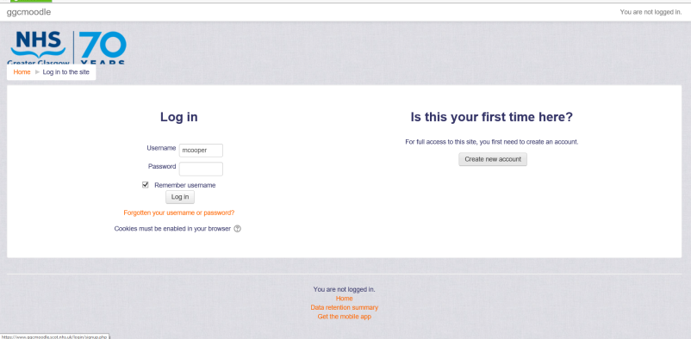
And follow the onscreen instructions. Please create the account using your workplace email address.
Once you have created an account you’ll be able to log in.
Navigate to: Care Homes, then Confirmation of Death.
The first time you try to access this course you’ll be asked for an enrolment key.
The enrolment key is: covid19
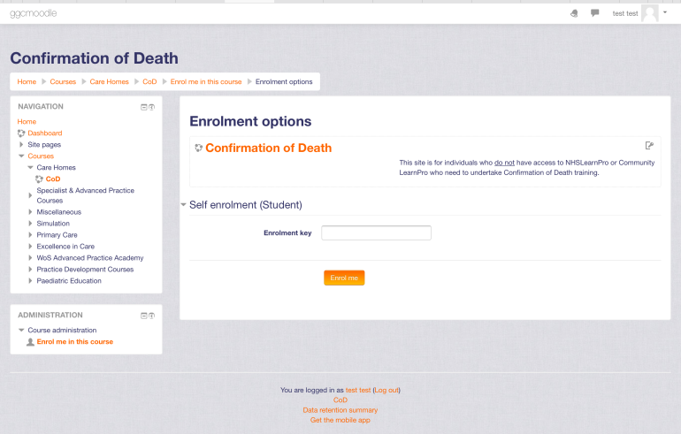
Here you’ll find a link to the Palliative Care Confirmation of Death website and the
GGC237 Confirmation of Death LearnPro eLearning package.
Any problems please email cod@ggc.scot.nhs.uk
Please note that you will not have access to any other site on GGCMoodle and your GGCMoodle account will be deleted when the Covid-19 pandemic is over.
The GGCMoodle version doesn’t have the ‘test’ at the end. However this test is not critical to completing training.

