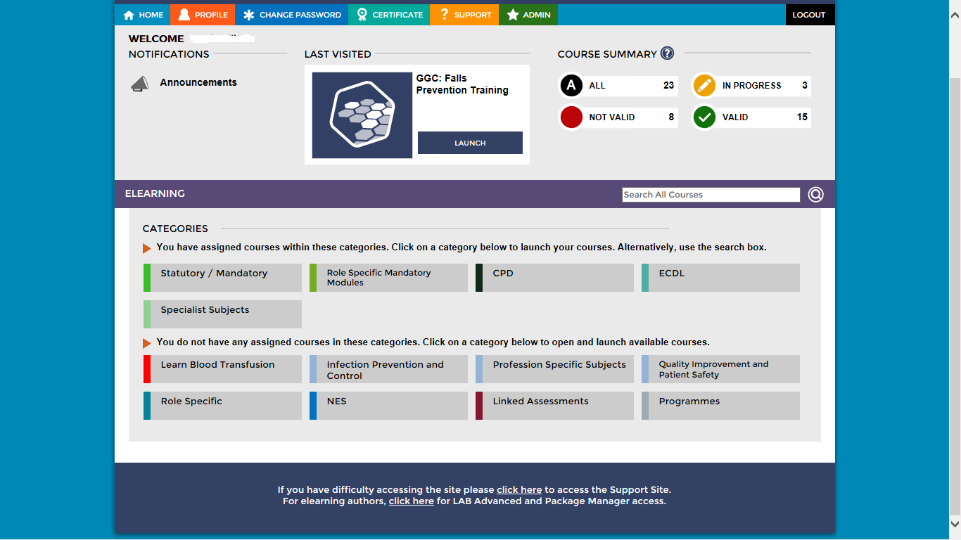
Log in to your LearnPro account as normal. Your home screen will be similar to this.

To illustrate how to add a module we have chosen GGC: 234 RN Update – Covid-19 Contingencies, (which sits under the Role Specific Mandatory category). Other courses can be found by clicking on other tabs.
GGC 237: Confirmation of Death sits under the same category

Click on the Role Specific Mandatory category.

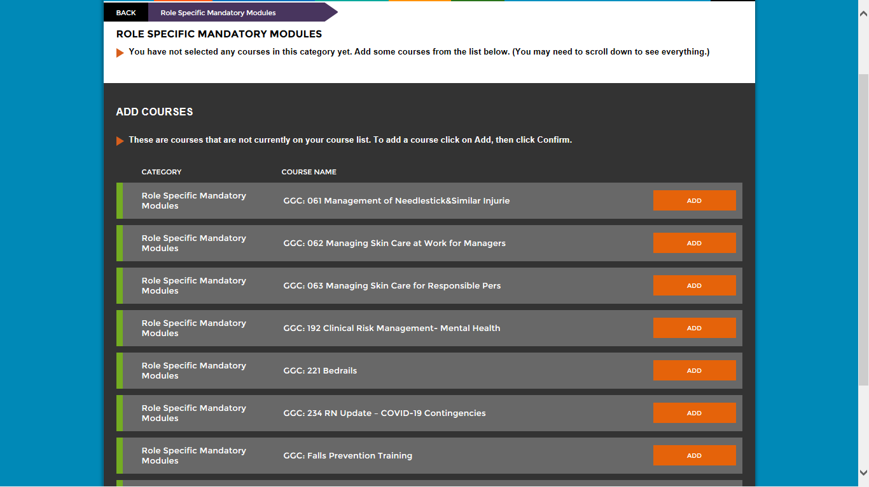
This screen appears.

You may have to scroll down to find the module.

Select the module by clicking on the ADD button next to the course title and confirming.

You will now have access to the selected course.

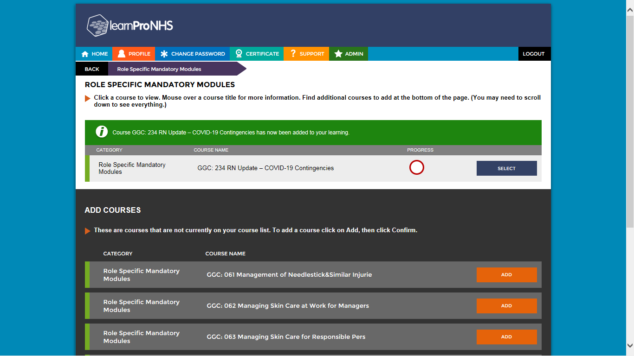
The module is now available to you.

To access the course click SELECT.

