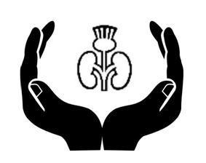

SCOTTISH RENAL SUPPORTIVE CARE GROUP

Wednesday 23rd October 2019
2-5pm

Easterbrook Hall, Dumfries & Galloway, DG1 4TL

Programme

Scottish Staffing Survey Results – Dr Mike Sullivan
Supportive Care Model – Drs Claire Douglas & Maureen Lafferty
Future Care Planning – Tricia Sutherland & Dr Pamela McKenzie
Frailty, A New Gestalt? – Dr Alice Radley
Future Reporting Metrics – Dr Tara Collidge

Format will allow time for discussion, idea sharing and future planning.
Free to attend, all welcome.

