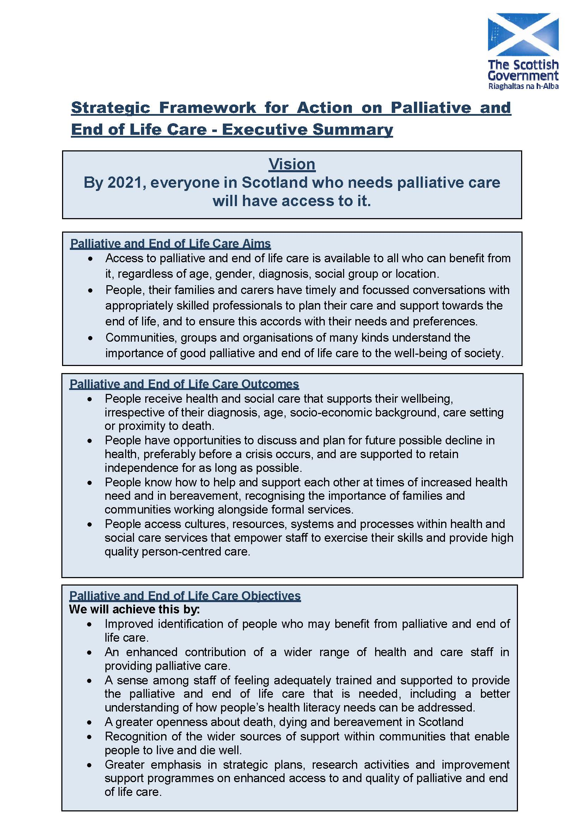

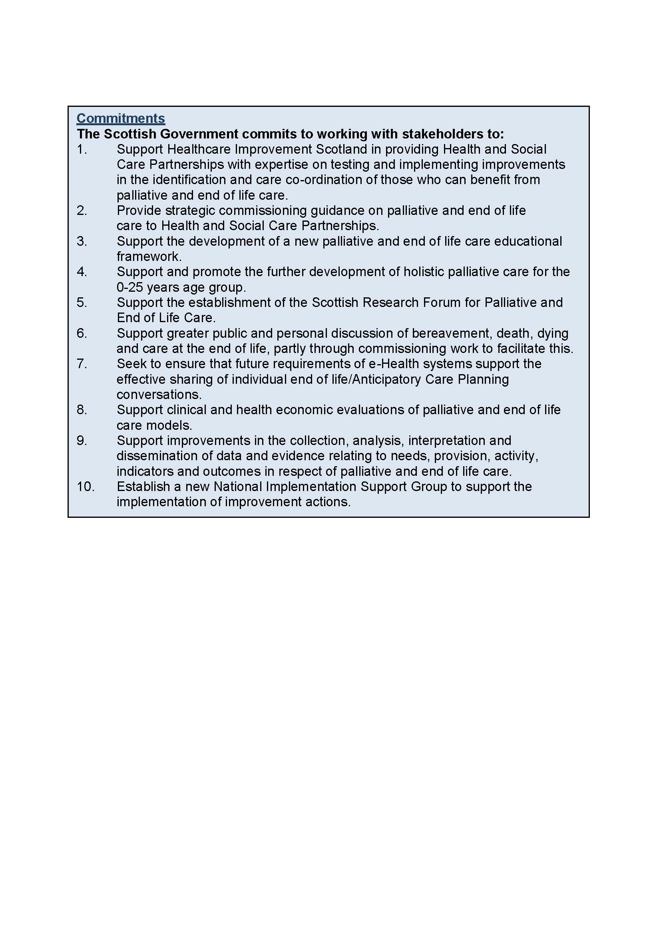
NHS Greater Glasgow & Clyde
Palliative Care Acute Group: Workplan 2016/18 Version 5 (7.11.17)
Building on the Terms of Reference agreed for the Acute Group (2016) and the Commitments and Objectives identified by Scottish Government through the Strategic Framework for Action on Palliative and End of Life Care ( December 2015) the Palliative Care Acute Group has identified its workplan as outlined below. It is recognised that, within the capacity available, this workplan may require to be altered to accommodate new national or local priorities.

Progress reports against workplan will be provided by Chair of Acute Group to Acute Lead Director for Palliative Care.

Topic area |  | Role: Lead/ Supporting / Influencing / others | Aim | Progress Report: as at Sept 2017 | Anticipated Outcomes  & completion date
1 | Service Delivery/Redesign
(a) | Equipment – T34 Pumps | Lead: J Kennedy/C O’Neill | All patients requiring CSCI will have access to CME Medical (McKinley T34) pumps, with associated governance structures | Scoping paper being prepared by CON  Issues around:  - Purchase  - Access  - Maintenance  - Training  19/9/17 CON working on report regarding T34 availability/ funding in acute. This is to be discussed at next meeting.  20/12/17 Ongoing to be discussed at next meeting 20th March 18 | Sept 2017: Paper to be submitted to Acute Lead Director for Palliative Care: funding requirements and benefits for patients/ organisation to be identified.  Positive impact on discharge of patients from acute.
(b) | Policies & procedures across HSPCTs | Leads: C Glen  C Broadfoot  ?CSM for women’s and children’s | Consistency of SOPs and annual reporting across HPCTs | All HPCTs have SOPs  No imperative from senior management to provide annual reports in senior management in Clyde or RS(W&C?)  Monthly service report template sent to group by CON. Each HPCT populates this template monthly and CON collates for JK, CSM and Clyde CN.  Dataset subgroup met June 2017 one off meeting, reconvene when clinical lead posts established.  19/9/17 JE/CON been informed by Marie Farrell that no extra activity report need at end of year. Teams to continue current practice. | Equity of access across sites, standardised practices including data collection  Sept 2017
(c) | End of Life Care | Leads: C O’Neill/CD/J Edgecombe | Ensure high quality end of life care in Acute, including appropriate support to facilitate EOLC in community | GAEL  - Embed into clinical practice – but how?  - Add link to GAEL in ITU software (where ITU have electronic records)  Deteriorating patient & DNACPR  - Pall care representation on GGC DP group (PK). Aim to keep GAEL etc on agenda  - Involvement with DNACPR Action Plan (JE)  Links with:  - Acute CG  - HSCPs  - Hospices  Identify barriers to good EOLC and PPC  Community Kardex – explore potential to commence use on GGC (C Mackay)  19/9/17 CON link with H I and T group re GAEL link on trakcare referral.  Updated NAD being piloted in acute area’s  20/12/17 Icon on desktop still ongoing. Button for Palliative Care on left hand side of staffnet page. Once clicked it will open to Adult and Child palliative care e resource folders. Group agreed for words no image on button.  An alert has still to be added to trakcare, when someone refers to the Hospital Palliative Care Team they are prompted to view the GAEL document. | In Scotland, similar to England and Wales approx 53% of deaths occur in hospital (acknowledge not all are anticipated): Patients and their families/carers to experience a good death. Inequalities in relation to choice: aim to support more patients to spend greater % of time at end of life at home or community setting
(d) | Commissioning of Acute Palliative Care Services by HSCPs | Leads: J Britton |  | NHS Healthcare Improvement Scotland has been commissioned by SG to develop commissioning guidance for HSCPs. Detail to date is limited around this: Acute Group will ensure that plans are developed to describe the services provided. | Commissioners are informed about the range, level and quality of service provided, links with 1B.
(e) | Reducing inappropriate variation/equity  Develop profile of capacity and demand within HSPCTs in GG&C | Lead: Claire O’Neill | Achieve equity of access to palliative care services across the Acute Division | Paper on HPCT establishment prepared 2016.  This work links with ‘1b’ in Redesign and ‘5b’ in E-health section of workplan).  20/12/17 Agreement paper was beneficial to highlight referrals and gaps in resources ie, IRH/VOL however, did not show variables such as length of stay. JE to update medical sessions and send to JM for dissemination to group.  JB highlighted that Palliative Care was not represented on moving forward together agenda. When JB enquired she was informed that specialties would involve/discuss PC within their own meetings. JB to send on David Stewarts email to JE. JE to contact David Stewart. | Identify any areas where greater efficiency could be achieved and improve equity of across GG&C: Increased early palliative care intervention will result in admission avoidance and earlier discharge for patients identified: improve performance on Quality Measure - % of last 6months of life spent at home or community setting.
2 | Patient Engagement
(a) |  | Lead: C O’Neill/P O’Gorman | Commitment to involve public in discussions around EOLC | CON sits on PACE (pt and carer experience gp).  Views of care at end of life questionnaire: pilot commenced May 2017. Significant difficulties with staff handing out questionnaires to bereaved families/carers.  Niall McGrogan, Head of Patient Experience, Public Involvement & Quality will support involvement with patient and cares for specific work streams.  19/9/17 CON gave group an update on this pilot aim for completion july 2018. | Greater public and individual discussion in relation to death and dying and individuals’ wishes
3. | Education & Training
(a) | In line with Commitment 3 of National Strategic Framework , ensure engagement in education framework being developed by NHS Education | Lead PD team | Awareness of NES Education Framework published May 2017 http://elearning.scot.nhs.uk:8080/intralibrary/open_virtual_file_path/i2564n4083939t/Palliative%20framework%20interactive_p2.pdf | The Framework identifies the knowledge and skills desired of all health & social care staff.  - Engage with Learning & Education and others to ensure this is visible to all staff in Acute.  - Ensure education programme including Communication Skills supports this Framework.  - Concerns raised by group around logistics of implementation of the Framework.  Elizabeth Sanchez-vivar attended meeting on 19th Sept 2017 to present framework. | Acute Sector training needs in relation to Palliative and end of life care identified and programme to deliver on these developed
(b) | Communication skills: focus on palliative and end of life care | Corporate Learning & Education Team  Organisational Development  CON |  | Participate in scoping of current provision of communication skills training – i.e. tools used/staff groups trained.  Participate in development and delivery of training plan: ensuring staff offered training appropriate to their role/grade.  7.4.17 update scoping underway next steering group meeting June 2017  19/9/17 Matrix being developed to provide consistency for staff accessing comms skills training. | Complement other work being undertaken in Acute to support learning culture and openness and trust: supporting Organisation and staff in relation to Duty of Candour
(c) | Provide training for acute colleagues (non-palliative care specialists) to support best practice in end of life care | Lead: PD Team |  | Encourage colleagues to access training opportunities provided through palliative care L&E calendar: also develop ad hoc training to support specific needs identified  30.5.17 link to pall care PD education calendar - Acute Palliative Care Practice Development Team - Education and Training Calendar | Palliative and end of life patients being cared for in all Acute settings will have enhanced quality of care.
(d) | Clarify future role/remit of Pan Glasgow Palliative Care PD Group | Lead: C O’Neill |  | If Group continuing ensure representation from Acute: ensuring connections between Acute workplan and Practice Development to support this: If Group not continuing, identify gaps this will leave in Acute: and how to address these. Ensure links with other training providers e.g. Hospices to identify gaps/duplication in provision.  Richard Kitchen and Graham Whyte will provide Palliative Medicine input to the Pan Glasgow Pall Care Practice Development GP.  19/9/17 Graham Whyte attended last meeting, next to be held in November.
(e) | Establish forum to share best practice/updates amongst palliative care colleagues and wider | Lead tbc |  | GGC Palliative Care Consultants group will be used as a forum for sharing best practice.  Role of GCPCNG?  19/9/17 JE informed group that Euan Paterson had Chaired a first meeting of the GCPCNG –Attended by Key individual services, 6 HSCP’s, Acute and Hospice settings. Next meeting Feb 2018. Directory being set up to act as node to disseminate good practice. Group will be reviewed in 1yr.
4 | Bereavement
 |  | Leads:  Sharon Lambie/ Elaine O’Donnell | Acute Palliative Care Group to represent views on actions/issues where GG&C Bereavement Group is seeking support from Acute Group. | Bereavement bag pilot complete Funding still to be confirmed.  EO’D feedback to the group that work was underway to update NHSGGC policies and literature.  19/9/17 8500 Bereavement Bags are being purchased and will be available to the acute setting and stored by procurement at 3 sites. Once this stock runs out wards will be funding thereafter. Promotion will be carryout once items are available.  Next Board Bereavement group meeting October 2017, group member to update acute group Dec 2017.  20/12/17 – Bereavement Bags now available throughout NHSGGC. CON is looking into ongoing funding of this resource.  National Bereavement Booklet now available which includes updated information on MCCD. ‘What can happen when someone is dying’ booklet. This is being updated at the moment and when going to print the image on front is to replicate the national booklet. DNACPR and Organ Donation teams are including information in NHSGGC booklet.  Bereavement Policy being finalized and then going live.  CP highlighted that there is Guidance on Staffnet for staff on how to take a child home from hospital after they have died if wised by the family. | Acute Group support for GG&C Bereavement Plan  Supporting patients and their families and carers.
5. | E-Health
(a) | Input to development and delivery of Palliative Care E-health workplan | Influence content of plan and deliver on issues relevant to acute settings  Lead J Britton |  | Key issues currently which Acute sector can support–  - Electronic referrals from acute HSPCTs to GGC Hospices now linked: next phase is wider CNS teams: Business case to support this submitted to E-health Team  - Medicines reconciliation project: support work being led by E-health team: next meeting of Palliative Care E-health meeting 15th September 2017  e-Resource group responsible for keeping resource folder up to date : all teams encouraged to review their pages on regular basis  19/9/17 JB informed group minimum dataset to be agreed (this will be taken forward when clinical lead posts established). Electronic prescribing pilot going ahead at IRH/BOC and Hospice which includes uploading to portal.  CON to re-explore PELC desktop icon.  20/12/17 – 5a – Discussions are taking place to try to create palliative care tab for PC letters on portal. QEUH HPCT currently setting up desktop scanner to facilitate this. JB to discuss with Joanne Friel.  JB also to discuss trakcare access for hospices | - improved communication/secure networks  - improved communication across all parts of system: reducing risk & improving quality  - Ensure accurate details are available for those accessing the services
(b) | Review of current databases in use across HSPCTs | Lead: C O’Neill/A McKeown/Mark Wotherspoon | Consistent data collection across sites. | HSPCTs to agree data items: KPIs which reflect services provided and work with E-health colleagues who will identify appropriate recording/reporting tools, ensuring data recording/reporting is secure and accurate.  No developments of minimum dataset from Scottish Government.  Meeting held on 12th June 2017 with all HPCTs represented- working on minimum dataset. | Consistency in data items recorded/reported and definitions: greater awareness of the role of the HSPCTs within acute settings: identification of opportunities for redesign &pressure points : preparation for future commissioning by HSCPs as per National Strategy 2015  Secure IT platforms: currently significant risk around these.
6. | Quality Improvement /Clinical Governance
(a) | GAEL | Lead: C O’Neill | Embed GAEL into clinical practice across Acute Division | GAEL now on staffnet as a clinical guideline and available to disseminate via pall care GGC/eolc  25 4 17 – GAEL audit tool – sent to the group with the proviso that if audits take place then the results are fed back via acute group/local clinical governance forums.  20/12/17 GAEL RAH PILOT – ongoing feedback to be given at next meeting 20/3/18. Audit from all areas discussed at meeting with agreement that work/results should be highlighted/feedback at this group. Audits of case notes happening at RAH, GRI and QEUH. Concerns were raised through BOC audit that death certificates not always being copied – this has been highlighted to BWSCC clinical managers. | Support delivery of care to patients at end of life and provide practitioners with information on resources available to them in doing so: this is particularly important for staff outwith HSPCTs caring for patients
(b) | Test of Change GAEL - RAH | Lead: D Gray |  | Medical Staff Views of Death and Dying Questionnaire, leading to:  Working with colleagues in 3 adult wards at RAH (Medicine, Surgery and Older People) to test out application of GAEL | Interventions at end of life will be appropriate: with focus on quality of care for individual patients in accordance with CMO Report on Realistic Medicine 2016 and GAEL.
(c) | Tests of Change : QEUH/GRI | Lead : A McKeown/F Finlay |  | Quality Improvement Project: To identify appropriate active interventions ensuring focus on comfort and dignity at end of life. Identify how learning can be shared | Interventions at end of life will be appropriate: with focus on quality of care for individual patients in accordance with CMO Report on Realistic Medicine 2016 and GAEL.
(d) | National Palliative Care Guidelines | Support development of national work  Leads C O’Neill, M O’Riordan L Kelly | Update guidelines | Following email from Dr. B Robson indicating HIS taking lead role: identify Acute Group representative(s) who will participate in this virtual peer review group Chaired by Dr. Pryde, NHS Fife: ensure engagement with wider Acute Group colleagues – and beyond, as appropriate.  Work ongoing  Acute group update December meeting | Development of Guidelines  by multidisciplinary group which are fit for purpose
(e) | SPSP Deteriorating Patient | Support : P Keeley |  | Acute Palliative Care Group to ensure it supports delivery of actions identified which are relevant to acute settings: next meeting of Deteriorating Patient Group 12.9.17
(f) | Compassionate Inverclyde | Lead E Anderson |  | As part of wider Compassionate Inverclyde Project the aim of this project would be to introduce a volunteer-centred programme providing companionship or dying, hospitalised patients so no one dies alone:  Pilot September 2017
(g) | Building on the best | Lead D Gray |  | Joint project from SPPC and Macmillan to Build on what is done well around communication/decision making. RAH may be pilot site.
(h) | National ACP |  |  | Launched June 2017. App available.  Link: http://ihub.scot/anticipatory-care-planning-toolkit/  Copies being sent to GPs and Care Homes, other copies to be printed locally.  HIS Pall Care Leads Medical: Paul Baughan, Nursing: Sandra Campbell  Social Work: TBC  Already some locally developed ACP documents in existence (to be sent to gp):  - NHS Lanarkshire Making Choices  - Glasgow City ACP
(i) | Medical Views on delivering EOLC | D Gray |  | Staff questionnaire sent – awaiting full analysis
7. | Audit & Research
 | National Research Forum | Support and influence  A McKeown / Diana Mcintosh |  | Engage with the National Forum chaired by Prof Bridget Johnston: two meetings held to date.  This is an open forum and info is on Scot Gov website | Learning from Research Forum is shared with all Acute colleagues, as appropriate and relevant action plans developed

