


Cancer Medicines Outcome Program (CMOP)
Patient Reported Outcome Measures (PROMs) Development Approach

Date: 24th March 2017
Time: 10:00am – 3:30 pm (Tea/Coffee from 9:30am)
Venue: Hamnett Wing (Rooms HW111 – 114), Strathclyde Institute of Pharmacy and Biomedical Sciences (SIPBS), University of Strathclyde

Aims of the day:
- Outline the CMOP programme funded by Scottish Government
- Provide an opportunity to share some of the current activities relating to PROMs in the context of cancer occurring across the UK
- Present an insight into the current published evidence on PROMs
- Stimulate discussion on the CMOP PROMs programme development approach to inform potential achievable deliverables within the CMOP programme timeframe

MORNING SESSION: Chair – Marion Bennie, Professor of Pharmacy, CMOP Academic Lead
10:00 – 10:15 | Introduction and welcome | Prof Marion Bennie
10:15 – 10:30 | CMOP Programme overview | Ms. Jennifer Laskey, CMOP Clinical lead
10:30 – 11:00 | The use of e-PROMS to improve chemotherapy toxicity management - results from a scoping review and evaluation in breast cancer patients | Ms Pinkie Chambers, Lead Pharmacist Applied Health Research, Cancer Services, University College Hospital NHS Foundation Trust.
11:00 – 11:30 | The use of ePROMs in the delivery of supportive care to people with cancer | Prof Roma Maguire, Prof of Digital Health and Care, University of Strathclyde; Ms Pamela Rose, Consultant Nurse Specialist, Transforming Care After Treatment Project, NHS Lanarkshire
11:30 – 12:00 | Patient Reported Outcomes in Myeloma: engagement and review approach | Ms. Jayne Galinsky, Health Service  Research Manager, Myeloma UK
12:00 – 12:15 | Open discussion

* 12:15pm – 1:00pm Lunch and networking *
AFTERNOON WORKSHOP: Chair – Jennifer Laskey, CMOP Clinical Lead
1:30 – 1:50 | Overview of PROMs evidence base in Prostate and Melanoma – programme approach | Mrs Emma D. Corcoran, Research Associate, University of Strathclyde
PROMs Programme Approach
1:50 - 2:50 | Workshop discussion on programme scope and approach (key questions) | Groups with CMOP team facilitators
2:50 – 3:30 | Group Feedback
3:30 | Event Close
Attendance
Please confirm attendance by emailing Steven.C.Brown@strath.ac.uk, including any specific catering requirements you have.
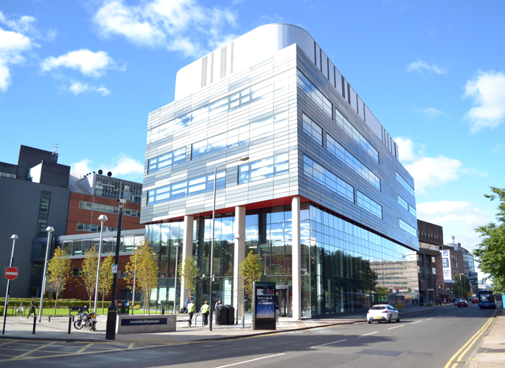
Directions
See http://www.strath.ac.uk/maps/ for an interactive map, searching for Hamnett Wing to find the building and rooms. The building is located on Cathedral Street, with entry through revolving doors. The rooms are located on the ground floor. The nearest train station is High Street, with all day parking available for £5 on High Street – it is located beside the train station. The building is also within a ten minute walk from Queen Street railway/subway station and Buchanan Bus Station.


