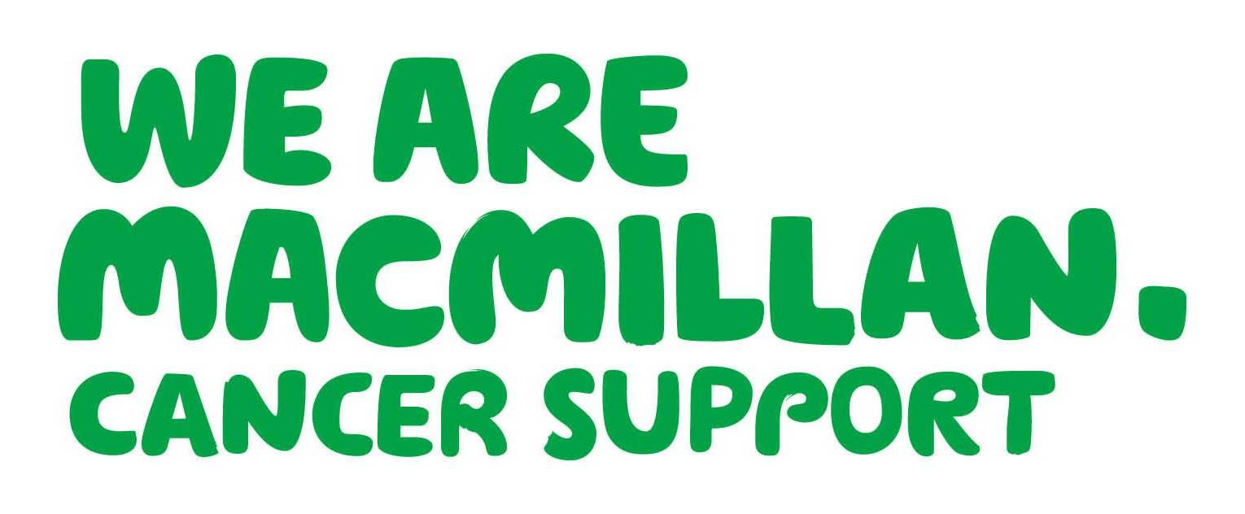
Renfrewshire Palliative Care Project Team

The Renfrewshire Macmillan Palliative care project team hope you all had a good summer despite our wonderful Scottish weather.

Doesn’t time fly, this is now the 4th newsletter from the project team and as we are now half way through our project we are now planning on going forward for the 2nd phase.

Key information regarding out of hours

Where to get Specialist palliative care help in the OOH

If you need advice from specialist palliative care services in the OOHs period, it is available from:

- A Palliative Medicine Consultant through RAH switchboard on 0141 887 9111

- The staff on duty in your local hospice who are also available for advice and support
  - Accord
0141 581 2000
  - St Vincents
01505 705635

Don’t forget to consult your NHS Scotland Palliative Care Guidelines:

http://www.palliativecareguidelines.scot.nhs.uk/

Electronic Key Information Summary (eKIS)
An article was published in Augusts Scottish Medical Journal reporting on an evaluation of the impact of eKIS on OOH clinicians in Scotland. The eKIS is one of the first national shared electronic records enabling GPs to share information with unscheduled care providers. The evaluation found that patients willingly consent to share their data and that the patients who are benefiting include those with palliative, complex or multiple conditions. OOH clinicians would welcome more eKIS and wider sharing.

One of the author’s suggestions for improving eKIS was widening the access, particularly to community nurses.

Please note that community nurses now have access to eKIS via clinical portal, so we can see what our GP colleagues are recording and for whom.
- Can you think of someone who would benefit from an eKIS?
- Do you know some vital information for OOHs staff about a patient’s social care and support structures, how to access their premises, JiC box (where it’s kept!), PoA or their wishes for future care that should be in the special notes?
Bet you can and do.....so lets start talking to our GP colleagues and influence the content of eKIS to ensure the best possible care for our patients and to support the decision making or our colleagues in the out of hours.
Reference:
Scottish Medical Journal 2015, Vol. 60(3) 126-131 An evaluation of the impact of key information summary on GPs and out of hours clinicians in NHS Scotland


SEPTEMBER DATE CANCELLED | Due to unavailability of venue this month has been cancelled.
14th October 15 | Financial Support – Liz Willis & Gillian Campbell from Advice works
NOVEMBER DATE CANCELLED | Due to unavailability of venue this month has been cancelled.
9th December 15 | Mairi Clare McGowan – St Vincent’s Hospice – Topic - TBC

Tea and Topic


If you have any suggestions for Tea and Topic please let the team know. These sessions have been very successful, you are all evaluating very highly therefore we are able to carry this into 2016. Thanks for all your support!
Contact us on 0141 314 4424 or macmillan.facilitators@ggc.scot.nhs.uk

CONTACTS.........................................

Our Public Climate survey.........

is still running. For those of us who live and work in Renfrewshire, we often find ourselves or our loved ones become the users of the services we all provide. Therefore if any of you feel that you would like to complete public climate survey to share your view or experience
Please Copy link below to access the questback questionnaire:

https://response.questback.com/nhsgreaterglasgowandclyde/j1lsmeuo7p/
Opportunity to record Reflection to support Revalidation
As we look to evaluate and plan our educational provision we would be grateful if you could take the time to complete our SELF REFLECTION TOOL. Once you have attended 3 training sessions provided by the Renfrewshire Macmillan Palliative Care Project, Alison will be in touch and ask you to complete the self reflection tool and share a copy with the team. Once completed, this could also be included in your PDP and REVALIDATION paperwork as evidence of learning. All of the information provided will be used to inform the overall evaluation of the project and will be reported anonymously. It is only by providing such evidence that we can hope to continue to provide educational opportunities like tea & topic which has proved to be very popular and worthwhile.
For more information contact us on 0141 314 4424 or macmillan.facilitators@ggc.scot.nhs.uk

