NHS GGC Palliative Care Education Template Fieldnotes
All education and training sessions will encompass the recommendations around the Strategic Framework for Action on Palliative and End of Life Care (2015)
The following is instructions on how to:
- Access the NHS GGC Palliative Care Education Template
- Complete the NHS GGC Palliative Care Education Template
  - A Key on the themes and sessions is highlighted at end of fieldnotes
    - Themes
    - Settings

How to access the NHS GGC Palliative Care Education Template
- If when open it doesn’t look like this, please refer to instructions below:

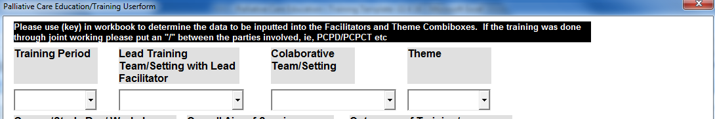
  - Click on the Options button above the spreadsheet
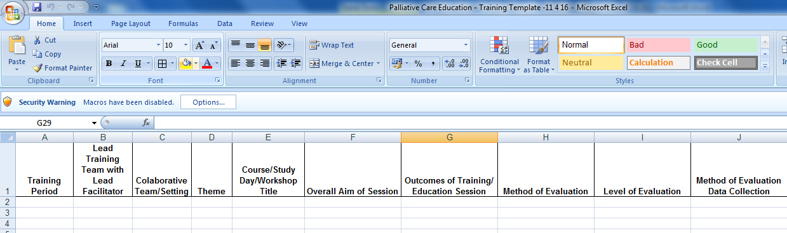
  - Choose to enable this content
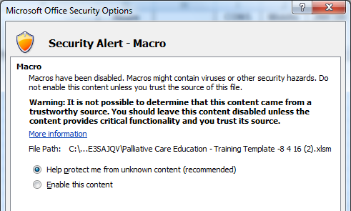

  - You are now able to input your training and educational sessions into the form.

How to complete the NHS GGC Palliative Care Education Template

Click into each box in input the data as per the table below:
Field | Description | Action | Information Required | Example
Training Period | This is the period in which the training was captured. | Click on arrow at side of box and choose appropriate training period. | Please choose the 3 month period the training covers. | Jan/Mar 16
Lead Training Team with Lead Facilitator | This is the Lead Training Team/setting with the name of the Lead Facilitator organising the training or education event | Click on arrow at side of box and choose appropriate team | Please choose appropriate team facilitating training and type in the name of the Lead Facilitator | If palliative care study day was being organised in the community setting with Shirley leading this training it would be for example, ‘PCPCT – Shirley Byron’
Collaborative Setting | This is if there has been any joint working with other teams/settings. Those teams/settings being asked to help with the facilitation do not include this information in their submissions. | Click on arrow at side of box and choose appropriate team/setting. If more than one please type in manually. See Settings below for key descriptions. | Please choose appropriate team/setting. If more than one please type in manually | If there was joint working between the acute setting(lead) and Accord Hospice and PCPCT, this would be, Accord Hospice/PCPCT. If there was no collaboration then choose N/A
Theme | This is the theme in which the training comes under | Click on arrow at side of box and choose appropriate theme for your training course to sit under. See key below for key descriptions. | Please choose appropriate theme for your training to sit under | If the course is DNACPR, this will come under the theme of ‘Palliative and End of Life Care Training’ so choose ‘P&EOLC
Course/Study Day/Workshop | This is the name or the course/study day or workshop title | Click in the box and type the name of the course/study day or workshop title | Name of the course/study day or workshop title | Type the name of the course/study day or workshop title. Ie,  5 Day Palliative Care in Progress – Symptom Management Module
Overall Aim of Training/ Education Session | This is to outline a brief aim of the training/education session | Click in the box and type a brief aim of the session | A brief aim of the session | Type a brief aim of the session, ie, ‘reflective and support session highlighting EOLC CAS Standards and rapid improvement work ‘
Outcomes of Training/ Education Session | This is to outline the learning outcomes for the training/education session | Click in the box and type a brief aim of the Training/ Education Session | A brief outline of the learning outcomes for the training/education session | Type a brief outline of the learning outcomes for the training/education session, ie, for Stat/Man training:  - Recognition of each member of staff’s responsibilities in relation to key areas of statutory and mandatory requirements in relation to their role  - Know how to access further information and advice on these subjects
Model of Evaluation | The Model of evaluation used, ie, Kirkpatrick, Phillips or Return of Investment. (ROI) (see definitions for further information) | Click on arrow at side of box and choose appropriate model | The Model of evaluation used, ie, Kirkpatrick, Phillips or Return of Investment | If the model used was Kirkpatrick, click on this. If no model was used please choose this.
Level of Evaluation | There are 5 levels of evaluation. (see definitions for further information) | Click on arrow at side of box and choose appropriate level of evaluation | What level of evaluation was used to evaluate the training/ education session | If this was a Level 1 then choose this from the options
Method of Evaluation Data Collection | This is the method used to capture the evaluation of the training/education session | Click on arrow at side of box and choose appropriate method used to capture the evaluation  of the training/education session | Choose a method from the drop down box, if the method is not given manually type in | If the evaluation is a questionnaire at end of training/education session then choose this from list
Method of Evaluation Follow Up | This is the method used to follow up the evaluation of the training/education session if appropriate | Click on arrow at side of box and choose appropriate method used to follow up the evaluation  of the training/education session if appropriate | Choose a method from the drop down box, if the method is not given manually type in. | If the follow up evaluation is a Questback survey then choose this from the list
Outcomes from Evaluation Results | This is the outcomes from evaluation results. Ie, use to improve future training/education events or summary evaluations sent to teams manager for training/education reports | Click on arrow at side of box and choose appropriate outcome from the evaluation results  of the training/education session | choose appropriate outcome from the evaluation results  of the training/education session | If the outcome evaluation results is just used to improve the course then, choose evaluations sent to teams manager from the list
Length of Session | The overall length in hours of training / education | Click in box and input number of hours in length the training education session takes | Figures only. Length in hours of course. Please discount time for lunch and tea breaks | Please type in for example, 5 hours.
No of Attendees | Number of Attendees | Click in box and input total number of attendees on course | Figures only. Total number of attendees | 40
Each Designation | Number of each designation attending the training, education course | Click in the boxes and input the number of appropriate designations attending the training, education course | Figures only. Input the number of appropriate designations attending the training, education course | Ie, if 3 registered nurses and 2 HSWS attended, input this into the respective boxes. Please note if there were no attendees for a particular designation please enter 0 in the box.

Key - Themes
Education Concept/Themes | Examples of Training Education Sessions
ACP Training | - Legal Aspects of Palliative & End of Life Care - AWI/POA  - MTAMP
Bereavement Training | - Loss, Grief and Bereavement  - Raising Public Awareness Sessions death, Dying & Bereavement
Communication Skills Training | - Rapport  - Sage and Thyme  - Foundation  - Intermediate  - Advanced
Other
Palliative Care 5 Day Module
Palliative and End of Life Care Training | - CAS – Standard 11  - Diagnosing dying/ prognostication e.g SPAR  - DNACPR  - GAEL  - Induction Training  - VOED
Pharmacy | - JIC
Professional/Personal Development | - Reflection/ VBRP  - Resilience Training
Spiritual Care
T34 Syringe Drive/Subcutaneous Route

Key – Settings

Settings | Key
Acute - PD and CNS | PCPD
Community - Macmillan | PCPCT
Community - Renfrewshire | RPCPT
Pharmacy Team | Pharmacy Team
Chaplaincy | Chaplaincy
Accord Hospice | Accord Hospice
Ardgowan Hospice | Ardgowan Hospice
Marie Curie Hospice | Marie Curie Hospice
PPWH | PPWH
St Vincent Hospice | St Vincent Hospice
St Margarets Hospice | St Margarets Hospice
Mental Health | Mental Health
N/A | N/A

If there has been any joint working with other teams/settings. Those teams/settings being asked to help with the facilitation do not include this information in their submissions.

Definitions
Model | Developed by | Definition
Kirkpatrick and Phillips | Donald L Kirkpatrick (1959; 1998; Kirkpatrick & Kirkpatrick, 2009)  Jack J. Phillips (1996) | The Four Levels of Evaluation, also referred to as the Kirkpatrick Evaluation Model, was created by Donald Kirkpatrick, Ph.D. to define the four levels of training evaluation. The four levels of evaluation are: (1) the reaction of the student and their thoughts about the training experience; (2) the student's resulting learning and increase in knowledge from the training experience; (3) the student's behavioral change and improvement after applying the skills on the job; and (4) the results or effects that the student's performance has on the business.  Kirkpatrick’s model is recommended by the NHS Greater Glasgow & Clyde Evaluation Review Group as the simplest, and probably most familiar, model to use.
Return on Investment (ROI) | Jack J. Phillips (1996) | Adds a fifth level of evaluation to Kirkpatrick model, to represent the Return On Investment (ROI) in training.  Phillips’ Level 5 is developed by converting Kirkpatrick’s Level 4 data to monetary values, and comparing these to the cost of the programme, to allow evaluators to determine whether a given programme is cost-effective. The processes involved in ROI analysis can be complex and resource intensive, however; also, it can be difficult to do in absolute terms, as many aspects can be very difficult to quantify or to define in precise financial terms. ‘Hard’ data, such as output, time, quantity, and costs, should be readily available and is relatively easy to calculate in monetary terms. ‘Soft’ data, e.g. absenteeism, turnover rate or other, subjective behaviours are harder to gather and more difficult to convert to a monetary value. In addition, soft data are often perceived as less valid than hard data.  Phillips himself states that, “Organisations should be considering implementing ROI impact studies very selectively on only 5 to 10 per cent of their training programme, otherwise it becomes incredibly expensive”. He goes on to indicate that most organizations settle on evaluating one or two sessions of their most popular programmes at this level, often using some form of sampling, and that for an organization implementing the ROI concept for the first time, it would make sense to select only one course initially, as part of the ROI learning curve.

